An example of Cognitive Load Theory through clear modular structure and sequencing
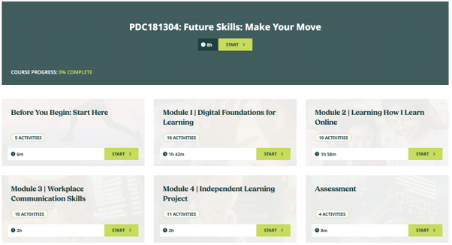

The course is organised into clearly defined modules, with each section displaying the number of activities and an estimated completion time. Breaking the learning journey into visible, manageable components provides learners with a clear overview of what lies ahead and reduces unnecessary complexity, closely reflecting the Toolbox’ emphasis on workload, sequencing and chunking.

An example of Scaffolded Learning through structured orientation and learner guidance
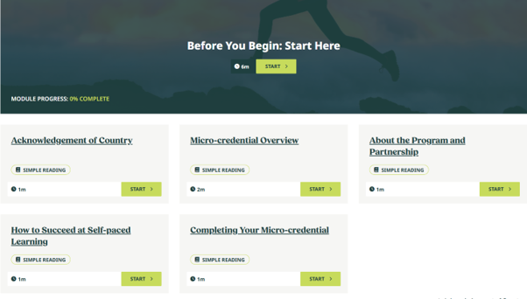

Before beginning the course content, learners are provided with a short, structured orientation covering the micro-credential, the programme, expectations for self-paced learning and how to complete the course. This provides early support and guidance that helps learners understand the learning environment before progressing more independently, closely reflecting the Toolbox’ definition of Scaffolded Learning.

An example of Self-Efficacy Theory through learning-to-learn support
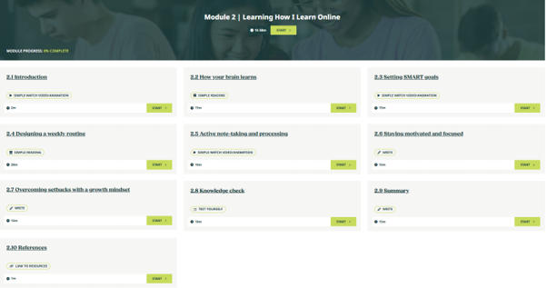
The module explicitly supports learners in developing strategies for successful online learning through activities on goal setting, weekly routines, motivation, managing setbacks and knowledge checking. These elements are closely aligned with Self-Efficacy Theory by helping learners build confidence in their ability to manage their learning, remain motivated and persist when difficulties arise.

An example of Experiential Learning through reflection and future application
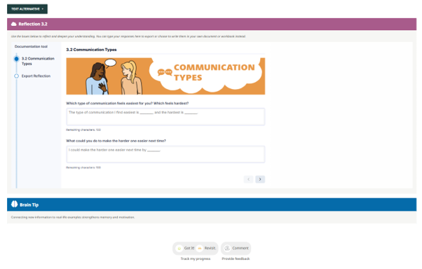
Learners are asked to consider which forms of communication they find easiest and most difficult and to identify what they could do differently in future. The activity connects learning with lived experience and encourages reflection followed by future application, directly reflecting the experiential learning cycle described in the Toolbox.

An example of Universal Design for Learning through flexible assessment expression
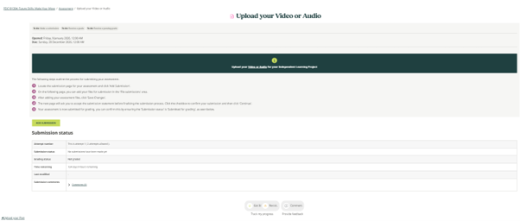
Learners are provided with the option to submit their assessment using video or audio, giving them flexibility in how they demonstrate their learning. This directly reflects Universal Design for Learning's emphasis on providing multiple ways for learners to engage with learning and demonstrate what they know.

