An example of Social Constructivism through structured synchronous interaction
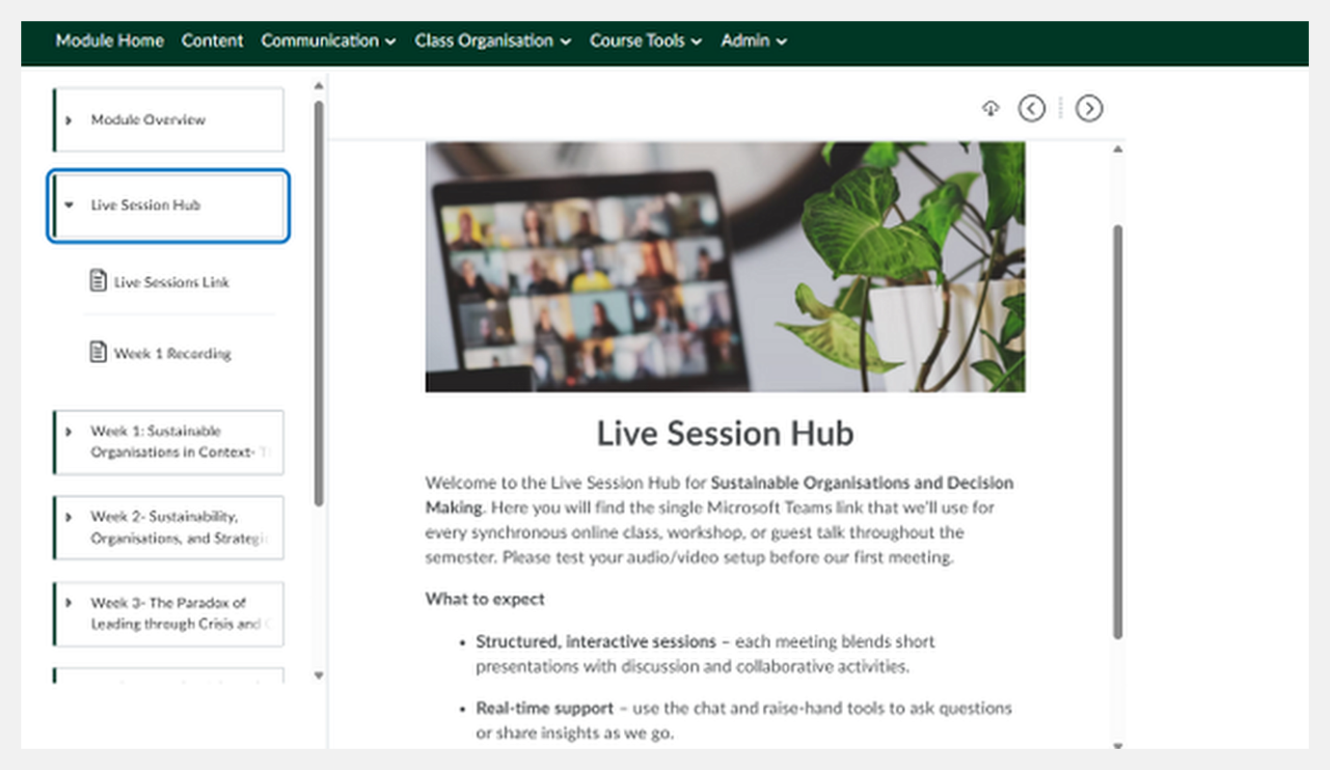
The Live Session Hub positions synchronous sessions as interactive learning spaces combining short presentations with discussion, collaborative activities and real-time learner participation. This creates deliberate opportunities for learners to develop understanding through dialogue, interaction and the exchange of perspectives with peers and the facilitator.

An example of Cognitive Load Theory through chunked and sequenced learning
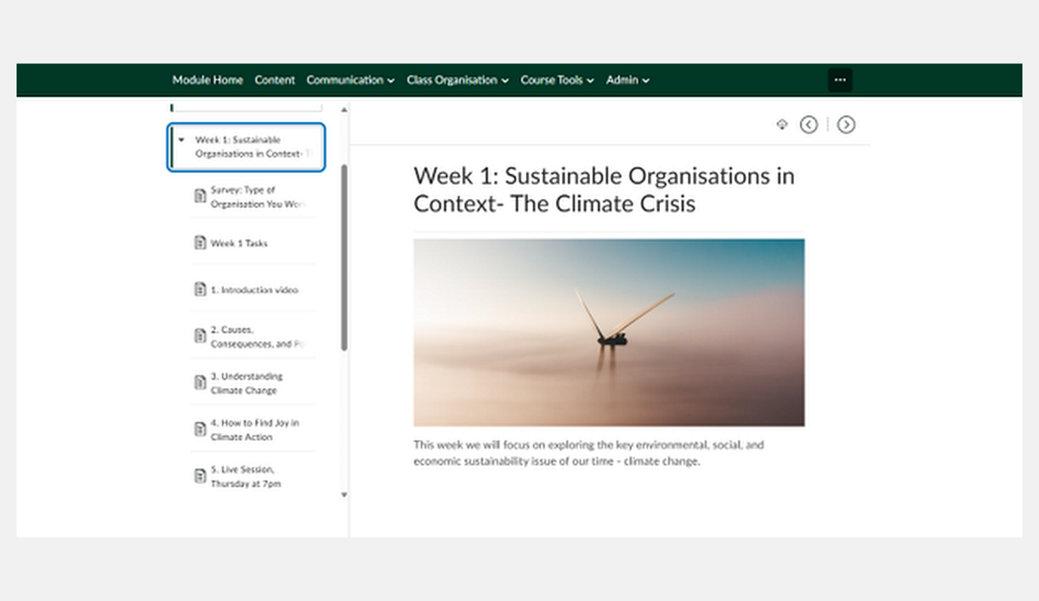
The week's learning is divided into clearly labelled, focused components (including introductory material, key concepts, activities and a live session) within a consistent navigation structure. Breaking the topic into manageable stages supports learners in progressing through complex subject matter without unnecessary cognitive overload, directly reflecting the framework's emphasis on sequencing, chunking and reducing unnecessary complexity.

An example of Adult Learning Theory and Social Constructivism through real-world case discussion
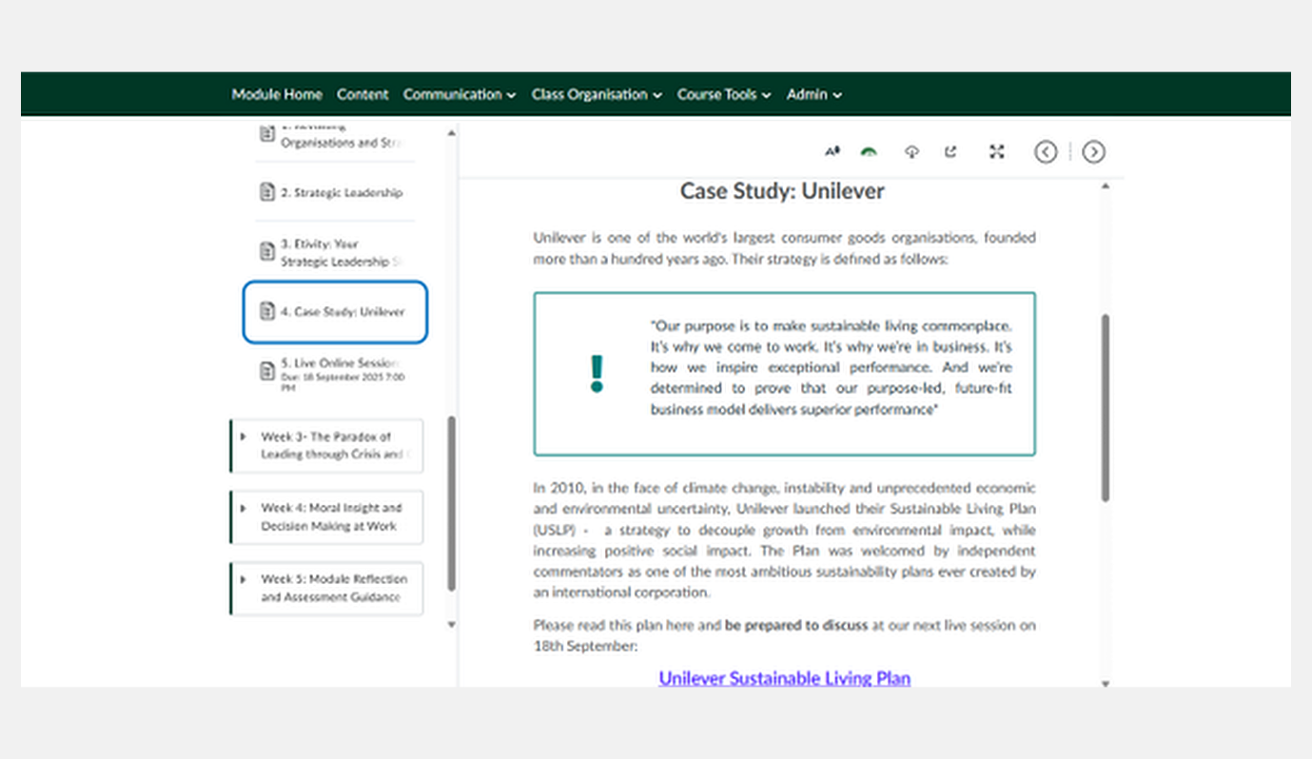
Learners engage with the real-world example of Unilever's Sustainable Living Plan and are asked to prepare to discuss it during the next live session. The use of an authentic organisational context makes the learning relevant and practically meaningful for adult learners, while the planned discussion creates an opportunity to develop understanding through dialogue and the exchange of perspectives.

An example of Scaffolded Learning and Self-Efficacy Theory through structured consolidation
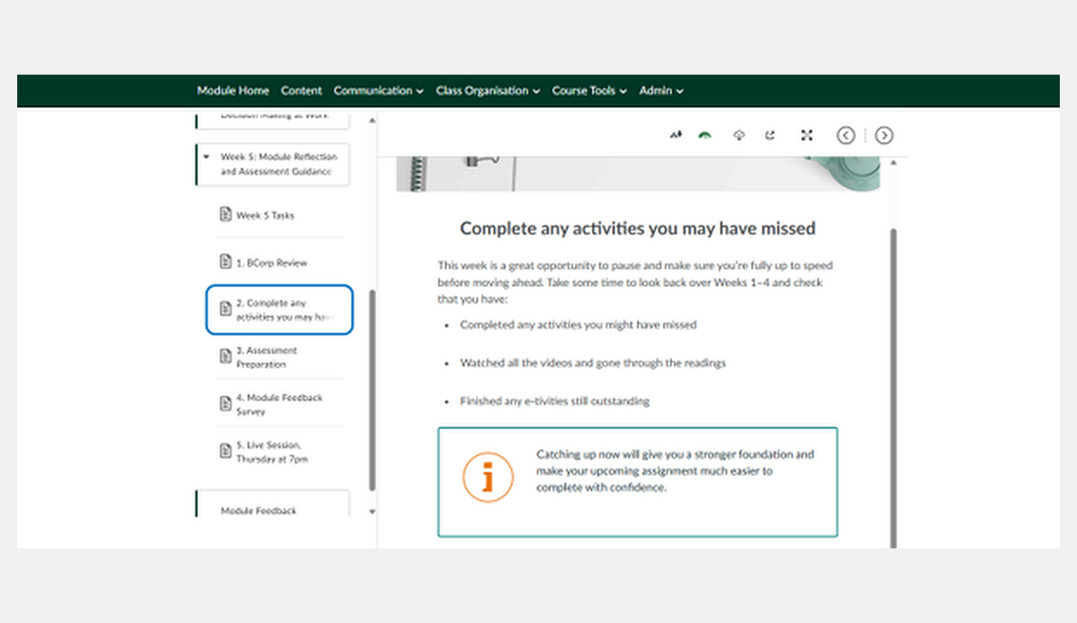
Learners are given a dedicated opportunity to pause, review their progress and complete any outstanding activities using a simple checklist of key actions. This structured catch-up point supports learners in managing their progress while reinforcing the message that consolidating earlier learning provides a stronger foundation for later assessment, helping to build confidence and persistence.

